Employ a layout algorithm suitable for bipartite graphs (e.g., Fruchterman-Reingold with appropriate node positioning).

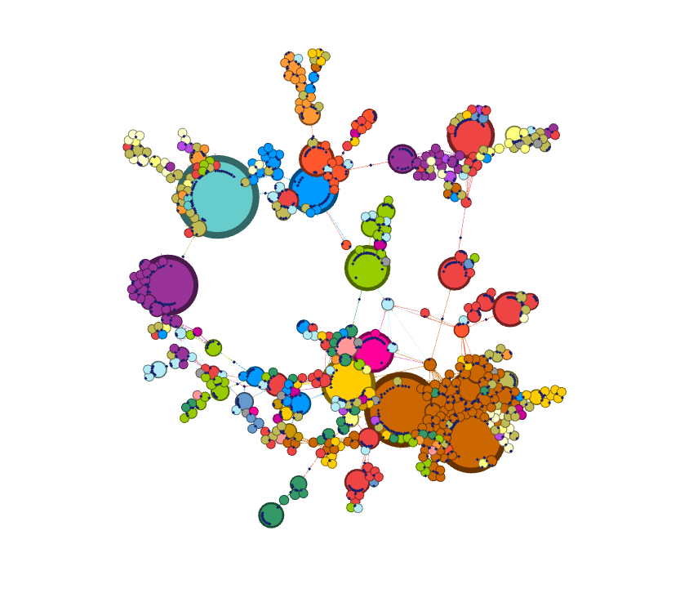

**Even Node Distribution:**

* **Reduces Overlapping:** Fruchterman-Reingold tends to distribute nodes evenly across the visualization space, minimizing overlaps and improving readability.
* **Enhanced Clarity:** By preventing node clutter, the algorithm enhances the clarity of the network structure.

**Preserves Global Structure:**

* **Captures Overall Pattern:** The algorithm aims to preserve the overall structure of the network, making it easier to identify general patterns and trends.
* **Reveals Relationships:** By maintaining the relative positions of nodes, Fruchterman-Reingold can help reveal underlying relationships between different parts of the network.

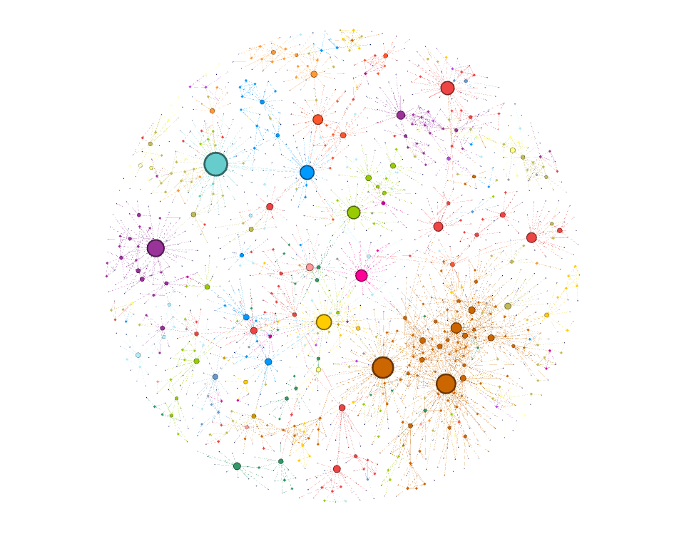

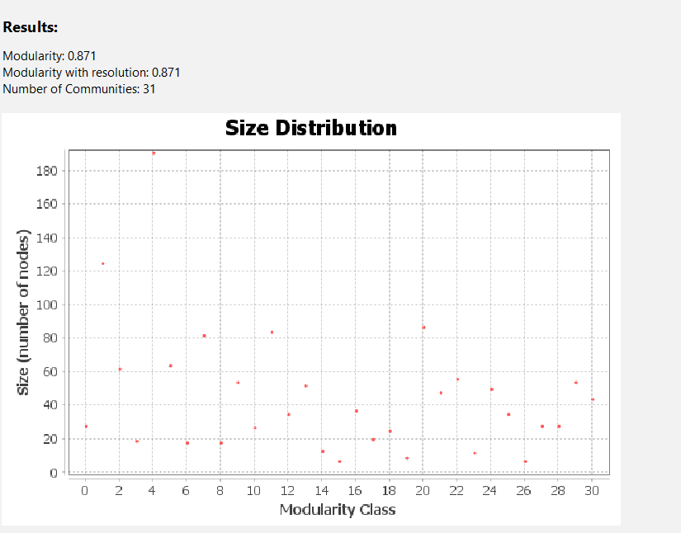

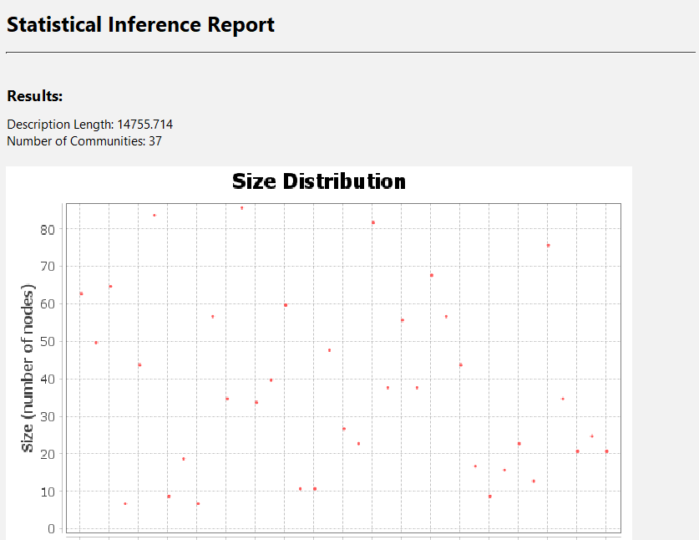

**Community Detection**

When you apply community detection algorithms to your diseasome network, you'll obtain a partition of the network into

**communities** or **modules**. Each community represents a group of nodes (diseases or genes) that are more densely connected to each other than to nodes in other communities.

* **Community membership:** Each node will be assigned to one or more communities.
* **Community size:** The number of nodes in each community.
* **Community density:** The average number of connections within a community.
* **Community overlap:** Some nodes might belong to multiple communities.

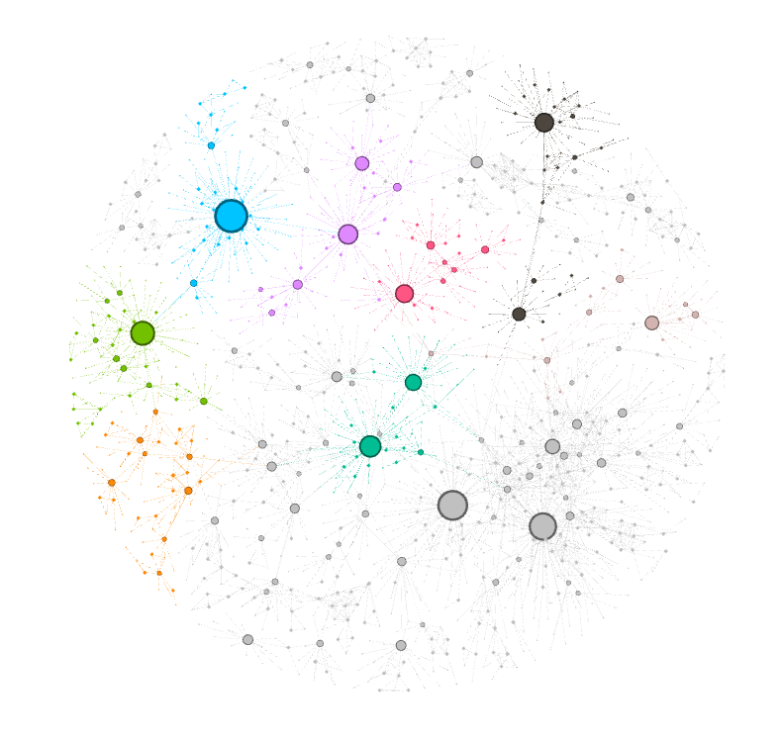

**Modularity**

Modularity is a metric that quantifies the quality of a network's division into communities. A higher modularity value indicates a better-defined community structure.

* **Modularity score:** A numerical value representing the overall quality of the community structure.
* **Comparison of modularity values:** You can compare modularity scores obtained from different community detection algorithms or different parameter settings to select the best partition.

**Statistical Inference**

While not directly provided by community detection algorithms, statistical inference can be applied to assess the significance of the obtained community structure. This involves determining whether the observed community structure is likely to occur by chance or if it represents a true underlying pattern in the data.

* **Statistical significance:** A p-value or confidence interval indicating the probability of observing the community structure by chance.
* 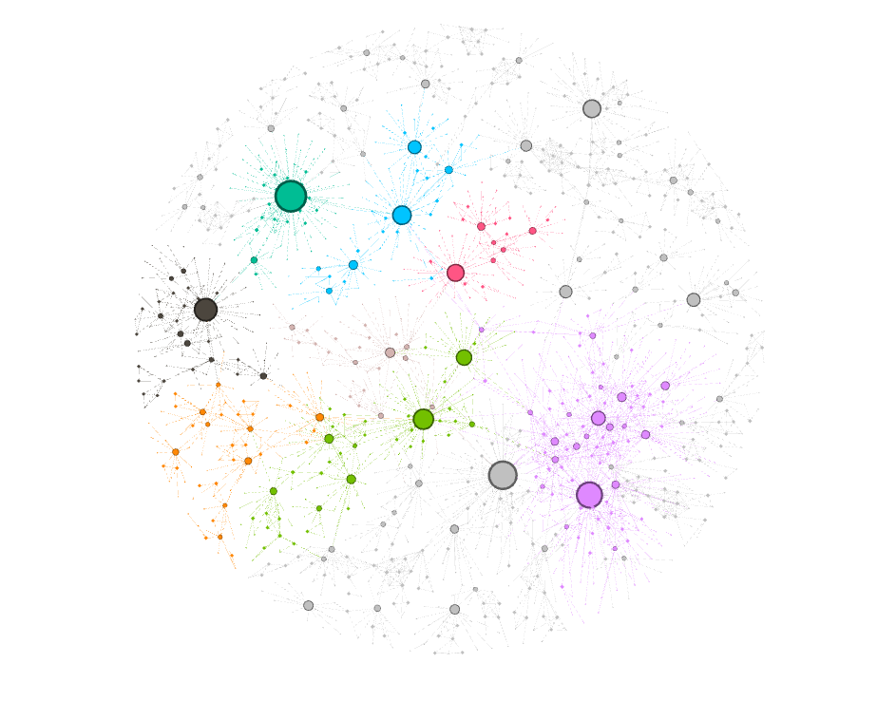**Comparison of community structures:** You can compare community structures across different datasets or time points to identify significant differences.

**Closeness Centrality**

* **Measures:** How close a node is to all other nodes in the network.
* **Information:** Identifies nodes that can efficiently reach other nodes. These nodes are often considered as potential influencers or spreaders of information.
* **Use case in Diseasome:**
  + **Key genes:** Genes with high closeness centrality might be crucial for the manifestation of various diseases.
  + **Disease hubs:** Diseases with high closeness centrality could be central to the spread of related diseases.

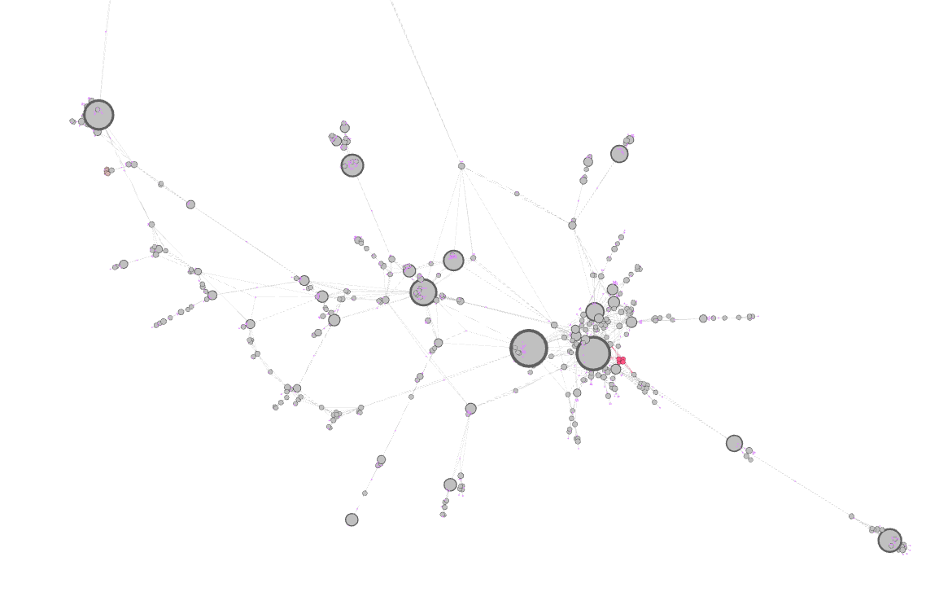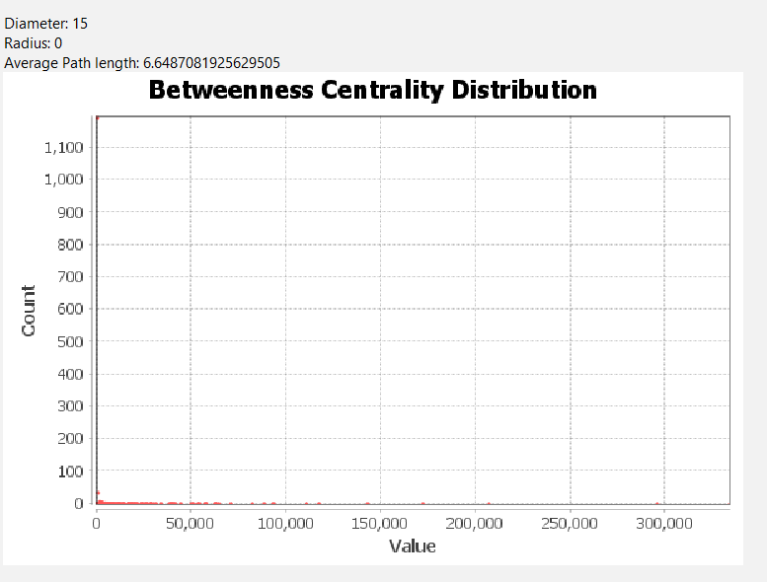

**Betweenness Centrality**

* **Measures:** How often a node lies on the shortest path between other pairs of nodes.
* **Information:** Identifies nodes that act as bridges or intermediaries in the network. These nodes are essential for information flow or control.
* **Use case in Diseasome:**
  + **Key genes:** Genes with high betweenness centrality might play critical roles in connecting different disease modules.
  + **Disease influencers:** Diseases with high betweenness centrality could act as intermediaries in the spread of related diseases.

